**Creating an AWS Account** is the first step you need to take in order to learn **Amazon Web Services**.

**Steps to follow are as follows :**

Step 1 – Visiting the Signup Page

Go to https://aws.amazon.com

You should see something like below:

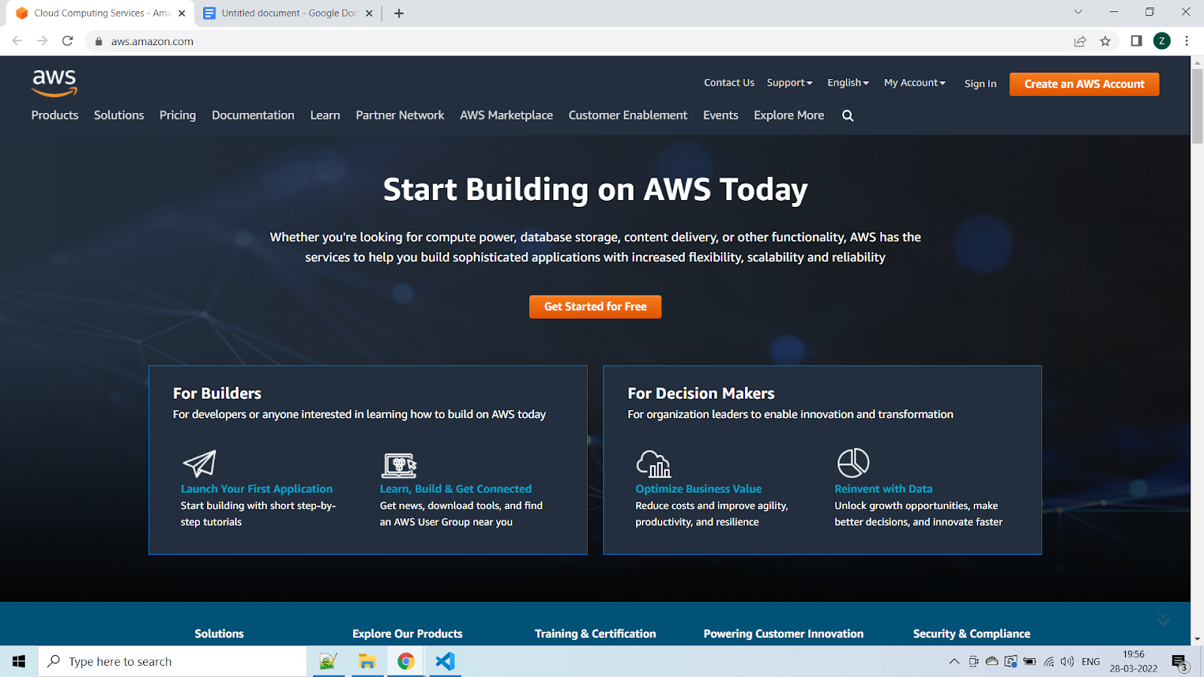

In order to continue, click the **Complete Sign Up** button in the middle of the screen or on the top right corner of the screen. You will see the below screen.

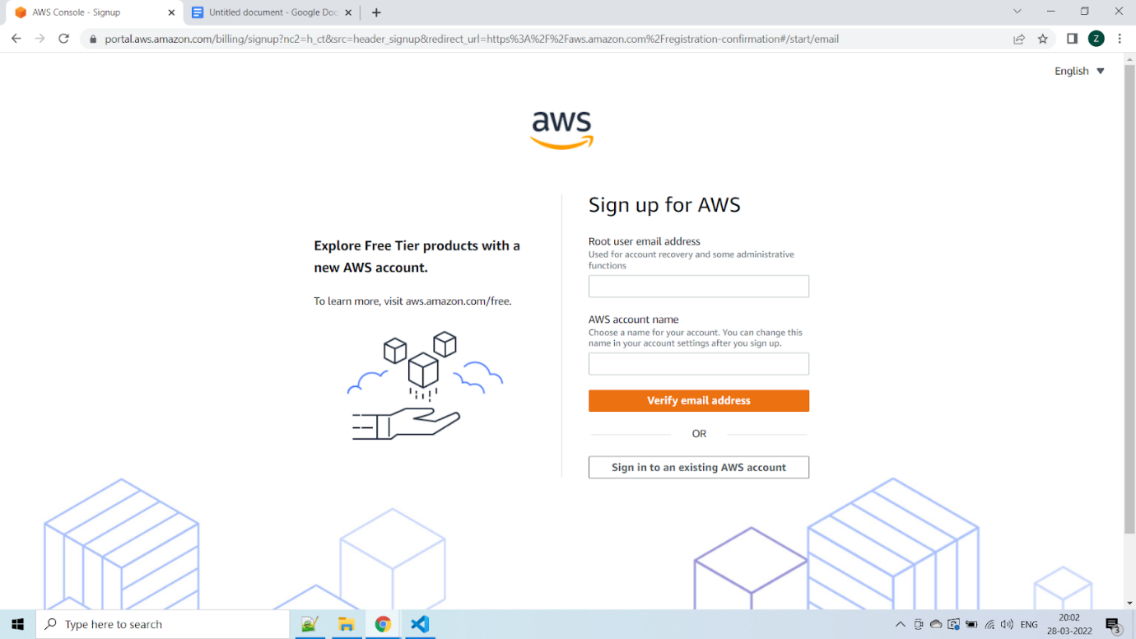

Step 2 – Entering User Details

After you have chosen to **Create a new AWS account**, you will see the below screen asking for few details.

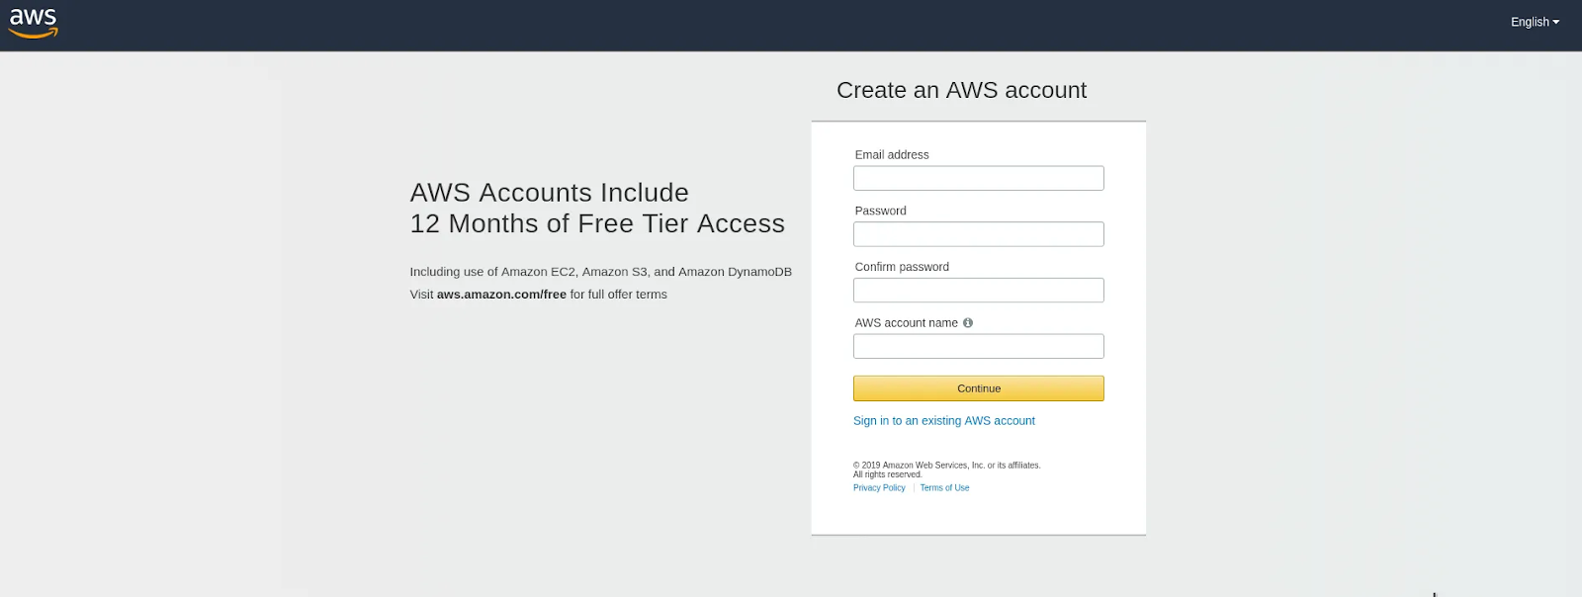

You can fill up the details as per your requirements and click **Continue**.

Next you will be asked to fill up your contact details such contact number, country, address and so on. You should fill them up properly because your contact number is important for further steps.

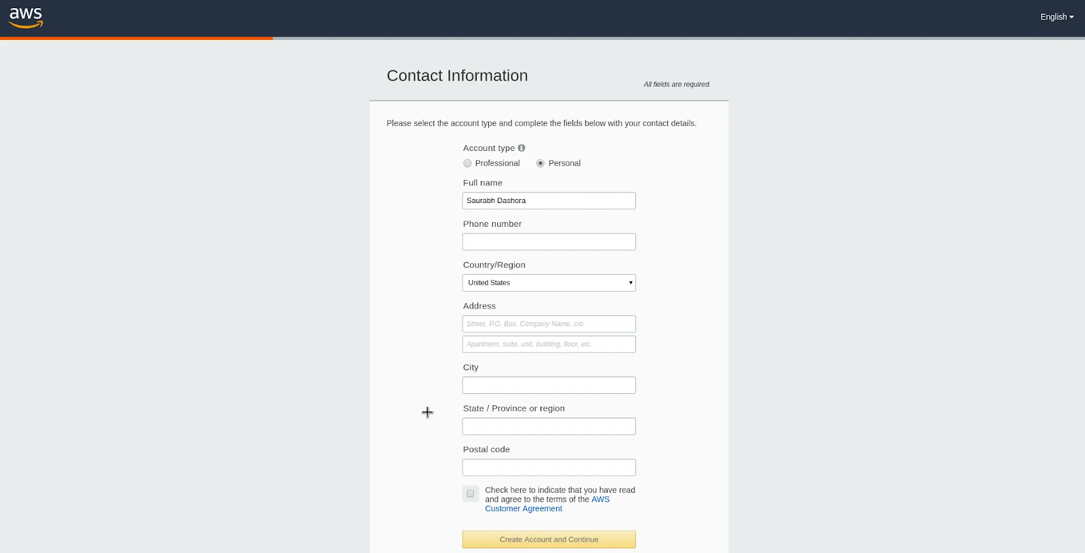

After filling up the details, click on the **Create Account and Continue** button at the bottom of the form.

Step 3 – Filling up the Credit Card details

For **Creating an AWS Account**, you need to enter your **Credit Card** details.

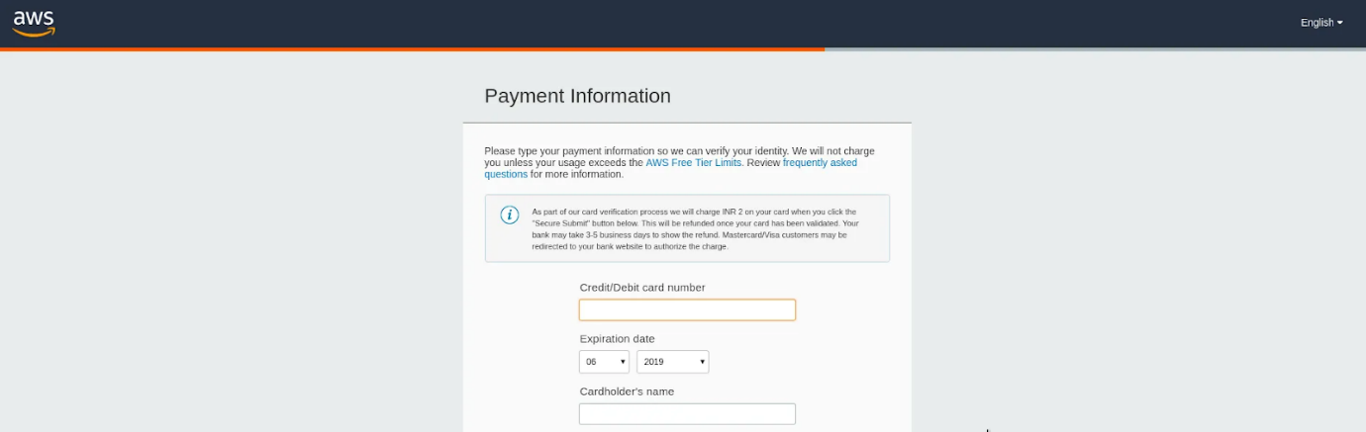

After entering the details, click on **Secure Submit** button. It might take a while to process the request depending on your bank/credit card company servers.

Step 4 – Identity Confirmation

Once the credit card details are confirmed, you will need to complete the **Identity Confirmation** step. You will see the below screen:

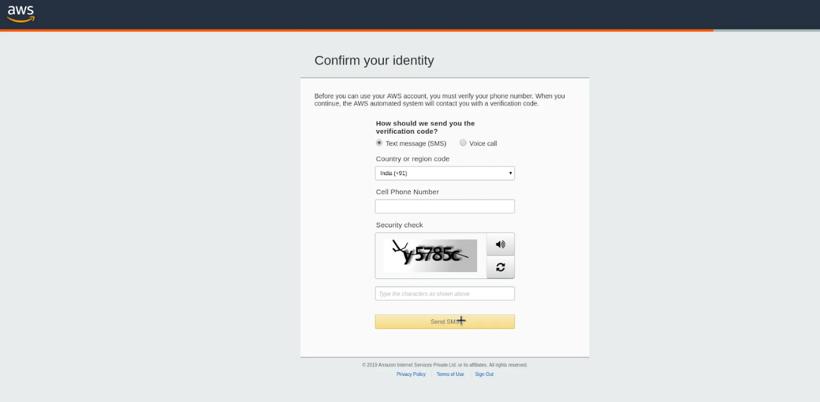

Once you have verified successfully, you should see a screen like below:

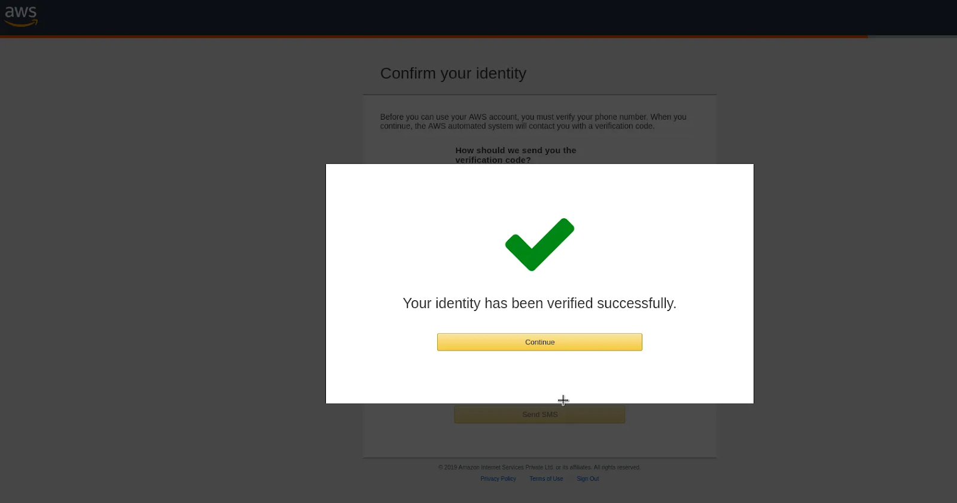

Step 5 – Selecting a Support Plan

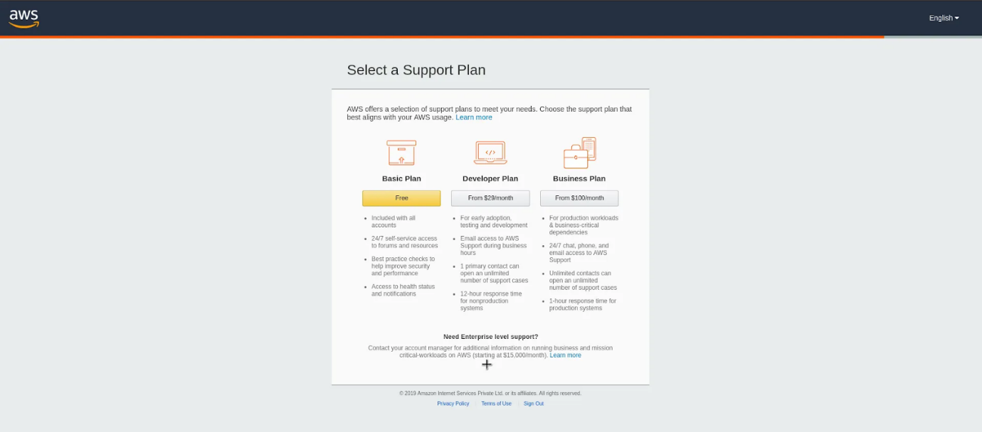

Go for **Basic Plan**. It is Free of cost and great for learning purposes.

The other plans are **Developer Plan** and a **Business Plan**. But both of them are paid options.

Once you select your plan, you will see the below **Welcome** screen. From here on, you can Sign in to your **AWS Console**.

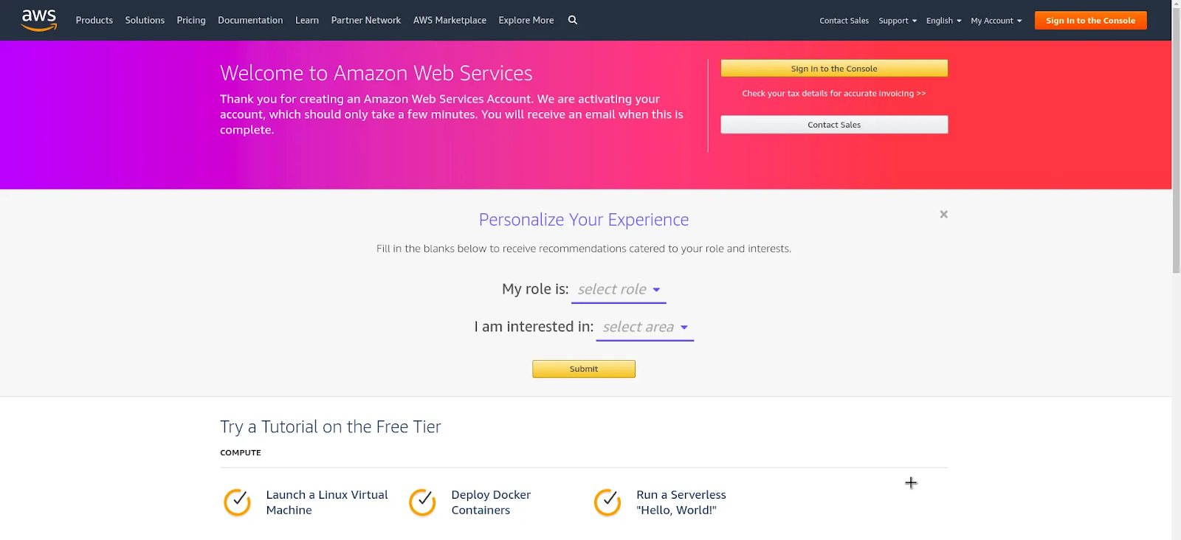

Finally, after logging in, you should be able to see the **AWS Management Console** as below:

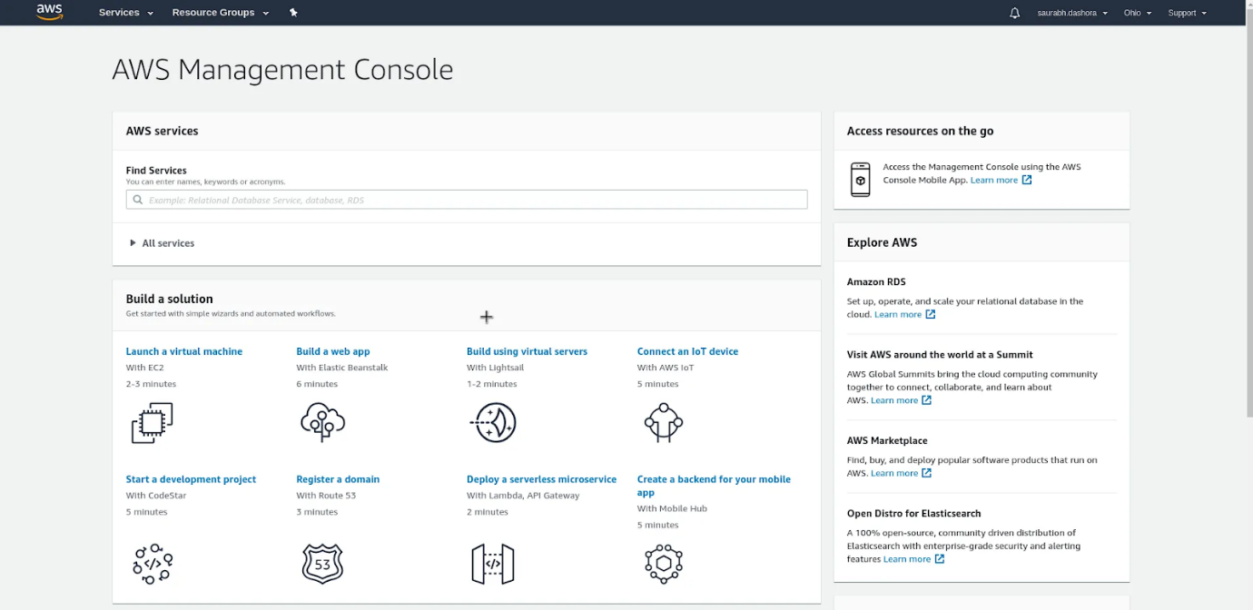

If you have reached this far, you have successfully finished **Creating an AWS Account**.